**Marieluise Fleiβer (1901 – 1974)**

Marieluise Fleiβer is best known for her critical dramas, though she also wrote short stories and an autobiographical novel. Fleiβer is associated with the genre of the *Volksstück*, called folk plays or milieu plays, which are written in dialect and intended for popular audiences. Her work and life were significantly impacted by her tumultuous relationship with Bertolt Brecht.

Fleiβer studied theatre and German literature for a time at the Munich University, where she met writer Lion Feuchtwanger and through him dramatist Bertolt Brecht. During this time she began writing, and her first stories were published in 1923. Her personal struggles took a toll on her health; in 1932 she attempted suicide, and in 1938 she was hospitalized due to a nervous breakdown. In an effort to escape political persecution, she married Sepp Haindl, a tobacco wholesaler, in 1935. During the next ten years she wrote very little, because she was forced to work and her writing was restricted by the government, but also due to poor health. She wrote some new material after the Second World War, and extensively revised numerous existing works to reflect the altered political and social state beginning in the late 1960s. **In 1953 she received the** literary award of the Bavarian Academy of Fine Arts.

Fleiβer’s best known plays are “Purgatory in Ingolstadt,” written in 1924, and “Pioneers in Ingolstadt,” written in 1928. Both stories take place in her hometown of Ingolstadt, Germany, where she spent much of her life; it is predominantly Catholic and has a strong military history. Fleiβer incorporates these aspects into broader critiques of repression, alienation, and exploitation. Bertolt Brecht and Walter Benjamin supported Fleiβer’s work, and with Brecht’s aid “Purgatory” was first staged in Berlin in 1926 and “Pioneers” in 1929, though he made unapproved changes that created a rift in their relationship. “Ein Pfund Orangen” is a collection of short stories first published in 1929. The protagonists are primarily subservient women; many are in fact maidservants, who have failed to comprehend their own commodification and objectification. Fleiβer wrote about what she knew, and from a contemporary perspective, her works illuminate several facets of German society directly preceding the rise of fascism. Her plays were revived during the 1960s, because they were seen as models for critical plays. In 1970 Rainer Werner Fassbinder made a film version of “Pioneers in Ingolstadt.”

**Key Works:**

Plays

Fegefeuer in Ingolstadt (1924)

Pioniere in Ingolstadt (1928)

Short Stories

Ein Pfund Orangen (1929)

**References and further reading:**

Case, S. (1992) *The Divided Home/Land: Contemporary German Women's Plays*, Ann Arbor: University of Michigan.

Hoffmeister, D. (1983) *The Theater of Confinement: Language and Survival in the Milieu Plays of Marieluise Fleisser and Franz Xaver Kroetz*, Columbia, S.C: Camden House.

**Images and online resources:**



Fleiβer and Bertolt Brecht, from <http://www.ingolstadt.de/stadtmuseum/frameset.cfm?url=http://www.ingolstadt.de/stadtmuseum/documents/ast_2001_marieluise_fleisser.htm>

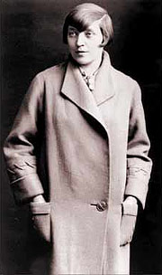

(probably the most used picture of) Fleiβer, also from <http://www.ingolstadt.de/stadtmuseum/frameset.cfm?url=http://www.ingolstadt.de/stadtmuseum/documents/ast_2001_marieluise_fleisser.htm>



Fleiβer, from http://blog.literaturportal-bayern.de/2010/11/22/marieluise-fleiser/

**Other interesting and pertinent links:**

http://www.fleisser.net/index.php?option=com_content&view=article&id=26&Itemid=48

* Link to a biography of Fleiβer, in German, English and French, on the website of the Fleiβer Society

http://www.ingolstadt.de/stadtmuseum/

* The city of Ingolstadt’s library houses Fleiβer’s archive. The information is under Stadtarchiv at the top of the page, but I can’t get a permanent URL for it specifically. It’s all in German however.

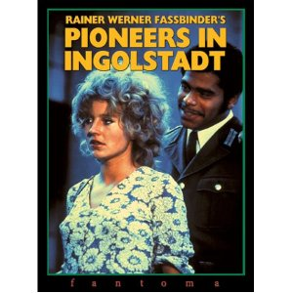

Cover of Fassbinder’s filmic version, from http://www.amazon.com/Pioneers-Ingolstadt-Hanna-Schygulla/dp/B0000AGQ68

http://www.fassbinderfoundation.de/en/filme_detail.php?id=14

* Information about Fassbinder’s filmic version of *Pioniere in Ingolstadt* in English, including a video clip and picture.

http://vimeo.com/41026490

* A recent US production of “Purgatory”